

**Source is fictional**

**Stanley House**

Photo:Lorena Armitage, March 23, 2014

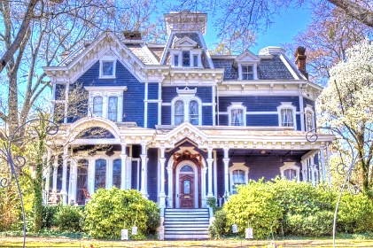

The first stop on your tour is located on the corner of Elm and Main Streets.   
  
This beautiful Victorian house was built in 1842 by the Van Dyne family, who were the founders of the Benton Button factory. By 1973 it had fallen into disrepair, but was purchased and restored by Dr. and Mrs. Earl Stanley. Dr. Stanley was the first African American professor at Midvalley State University and became the chairman of the Economics department before he retired in 2010.  
  
After admiring the house and its immaculately kept gardens, continue down Elm Street, and then turn right onto Cottonwood.

**Next stop >>>**

Walking Tour Stop 1: Stanley House

**Welcome to Midvalley!** **Historic homes walking tour**

Midvalley Tourism

